**Eye Diagram** - Received+filtered signal with AWGN overlapping for all possible binary input sequences

Eye diagram – digital signal which is repeatedly sampled and applied to vertical input

<https://www.microcontrollertips.com/eye-diagram-eye-pattern-oscilloscope-mean/>

Viewing eye diagrams can help with finding crosstalk, electromagnetic interference (EMI), signal loss and other phenomena that affect signal integrity. The term “eye” refers to the fact that the pattern on the oscilloscope looks like an eye. The bigger the opening of the “eye,” the better, in terms of signal to noise ratio. The general amount of jitter can be seen in the crossing.

The unit interval or bit period of an eye diagram is defined by the data clock. As mentioned above, the eye diagram displays all of the values, which are in variable positions due to noise or other factors, that a digital signal takes on during a bit period.  Noise and other factors can make the digital signal deviate from a train of perfect step functions in a stream of 0s and 1s, and this is cumulatively displayed in aggregate in the eye diagram. A closed eye indicates a noisy, unpredictable signal.

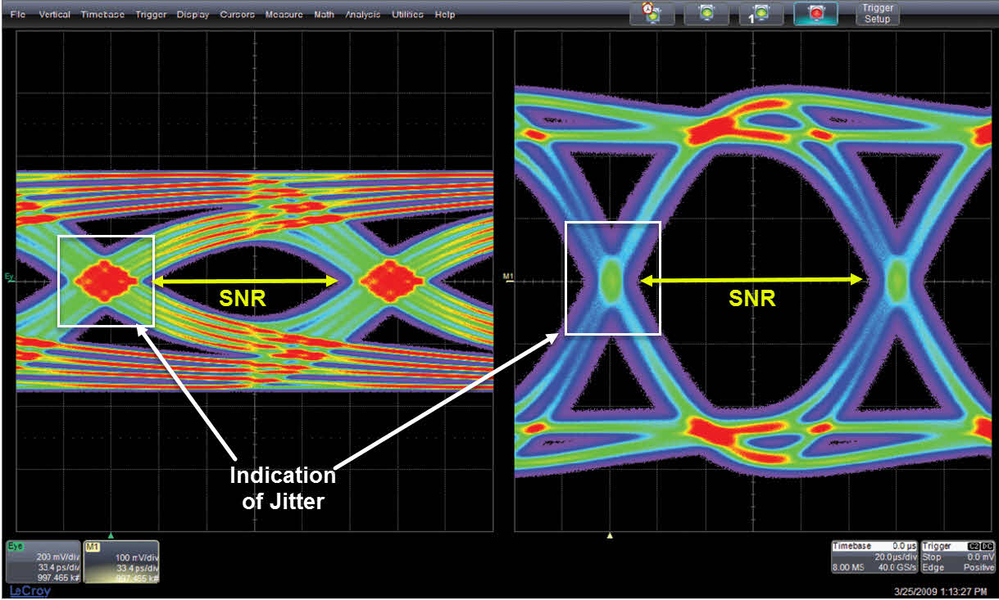

Equalization – adjusting the balance between frequency and input signal

In [telecommunication](https://en.wikipedia.org/wiki/Telecommunication" \o "Telecommunication), **equalization** is the reversal of distortion incurred by a signal transmitted through a [channel](https://en.wikipedia.org/wiki/Channel_(communications)" \o "Channel (communications)). **Equalizers** are used to render the [frequency response](https://en.wikipedia.org/wiki/Frequency_response" \o "Frequency response)—for instance of a telephone line—*flat* from end-to-end. When a [channel](https://en.wikipedia.org/wiki/Communication_channel" \o "Communication channel) has been equalized the [frequency domain](https://en.wikipedia.org/wiki/Frequency_domain" \o "Frequency domain) attributes of the signal at the input are faithfully reproduced at the output. Telephones, [DSL](https://en.wikipedia.org/wiki/DSL" \o "DSL)lines and television cables use equalizers to prepare data signals for transmission.

Equalizers are critical to the successful operation of electronic systems such as [analog broadcast television](https://en.wikipedia.org/wiki/Analog_television" \o "Analog television). In this application the actual [waveform](https://en.wikipedia.org/wiki/Waveform" \o "Waveform) of the transmitted signal must be preserved, not just its frequency content. Equalizing filters must cancel out any [group delay and phase delay](https://en.wikipedia.org/wiki/Group_delay_and_phase_delay" \o "Group delay and phase delay) between different frequency components.

In [telecommunication](https://en.wikipedia.org/wiki/Telecommunication" \o "Telecommunication), **intersymbol interference** (**ISI**) is a form of [distortion](https://en.wikipedia.org/wiki/Distortion" \o "Distortion) of a [signal](https://en.wikipedia.org/wiki/Signal_(electrical_engineering)" \o "Signal (electrical engineering)) in which one [symbol](https://en.wikipedia.org/wiki/Symbol_(data)" \o "Symbol (data)) interferes with subsequent symbols.

This is an unwanted phenomenon as the previous symbols have similar effect as [noise](https://en.wikipedia.org/wiki/Electronic_noise" \o "Electronic noise), thus making the communication less reliable. The spreading of the pulse beyond its allotted time interval causes it to interfere with neighboring pulses.[[1]](https://en.wikipedia.org/wiki/Intersymbol_interference#cite_note-1) ISI is usually caused by multipath propagation or the inherent linear or non-linear frequency response of a [communication channel](https://en.wikipedia.org/wiki/Communication_channel" \o "Communication channel) causing successive symbols to "blur" together.

The presence of ISI in the system introduces errors in the decision device at the receiver output. Therefore, in the design of the transmitting and receiving filters, the objective is to minimize the effects of ISI, and thereby deliver the digital data to its destination with the smallest error rate possible.

Ways to alleviate intersymbol interference include [adaptive equalization](https://en.wikipedia.org/wiki/Adaptive_equalization" \o "Adaptive equalization) and [error correcting codes](https://en.wikipedia.org/wiki/Error_detection_and_correction" \o "Error detection and correction).

Digital symbols are transmitted over a channel by means of pulses. Transmission lines (e.g., coaxial or twisted-pair cables) can be considered as low-pass channels. Such channels (linearly) distort the pulses such that **inter-symbol interference (ISI)** appears. This ISI generally prevents an easy detection by just sampling the received signal. It is therefore important to remove this ISI at the sampling times by proper equalization at the receiver. System theoretic reasoning leads to the 1st Nyquist criterion which is the fundament of equalization and enables dimensioning. There are several approaches for dimensioning. They can be characterized by time-domain or frequency-domain approaches.

In this lab exercise we study the transmission of a digital bit stream over a baseband (low pass) channel. Pulses are sent as U*rect(t/T0), NRZ, and the channel is emulated by an **analog low-pass filter** (cascade of RC blocks).

LP filter -> pass frequency is lower than cutoff frequency